Deep learning and IOT based automated disease detection

and pest classification in Potato Farming

Abstract

The management of crop pests and diseases in potato cultivation is a critical challenge impacting yield and quality. Traditional methods for pest and disease detection are often labor-intensive and time-consuming, leading to delayed interventions and significant crop losses. The integration of Internet of Things (IoT) and deep learning technologies presents a promising solution to enhance the efficiency and accuracy of pest and disease management in potato farming.

IoT devices, including sensors and cameras, can continuously monitor environmental conditions and crop health in real-time, providing valuable data on temperature, humidity, soil moisture, and visual symptoms of diseases and pests. These data are transmitted to a central system where deep learning algorithms process and analyze the information to identify early signs of infestations or infections. Convolutional Neural Networks (CNNs), a type of deep learning model, are particularly effective in recognizing patterns and anomalies in image data, enabling precise identification of specific pests and diseases.

The combination of IoT and deep learning not only facilitates early detection but also enables predictive analytics, allowing farmers to implement timely and targeted interventions. This approach reduces the reliance on chemical pesticides, promotes sustainable farming practices, and ultimately improves crop yield and quality. Moreover, the automation of monitoring and decision-making processes reduces labor costs and increases operational efficiency.

Leveraging IoT and deep learning technologies in potato farming provides a robust framework for effective pest and disease management. By enabling real-time monitoring, accurate diagnosis, and predictive capabilities, these technologies offer significant potential to transform traditional agricultural practices, ensuring food security and sustainability.

Flow of Deep learning and IOT based automated disease detection

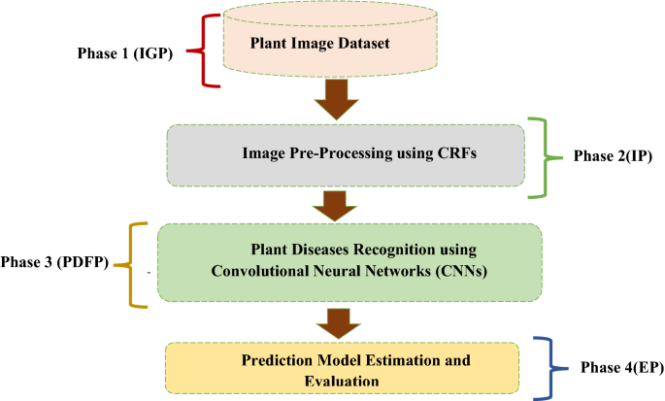

1. Introduction

In modern agriculture, leveraging advanced technologies like deep learning and IoT is revolutionizing potato farming by providing innovative solutions for disease detection and pest classification. Potato farming, which involves a series of steps from soil preparation, planting, and irrigation to harvesting, faces significant challenges from diseases and pests that can drastically reduce yield and quality. Traditional methods of disease and pest management rely heavily on manual inspection and chemical treatments, which are time-consuming, labour-intensive, and often environmentally harmful.

The integration of deep learning and IoT in this context offers a transformative approach. Deep learning, a subset of artificial intelligence, can be employed to develop sophisticated image classification systems. These systems analyse images of potato plants captured by IoT-enabled devices, such as drones and ground-based sensors. By training on large datasets of diseased and healthy plants, the deep learning models can accurately identify symptoms of various diseases and pest infestations at an early stage.

Executing this process begins with the deployment of IoT devices in the potato fields. These devices continuously monitor the plants and collect data, including high-resolution images. The images are then processed by deep learning algorithms, which classify them based on the presence or absence of disease symptoms or pests. When a potential issue is detected, the system can alert farmers through a user-friendly interface, providing them with detailed information and actionable insights.

One of the key advantages of this approach is real-time monitoring. Farmers receive immediate alerts about potential threats, enabling them to take prompt action and prevent the spread of diseases or pests. This early intervention is crucial for maintaining the health of the crop and ensuring high yields. Moreover, the system's ability to analyse large volumes of data quickly and accurately reduces the need for manual inspections, saving time and labour costs.

Additionally, this method promotes more sustainable farming practices. By accurately identifying problems, farmers can target their interventions more precisely, reducing the need for broad-spectrum chemical treatments. This not only lowers production costs but also minimizes the environmental impact of farming activities. Furthermore, historical data collected can help in predicting future outbreaks and planning preventive measures.

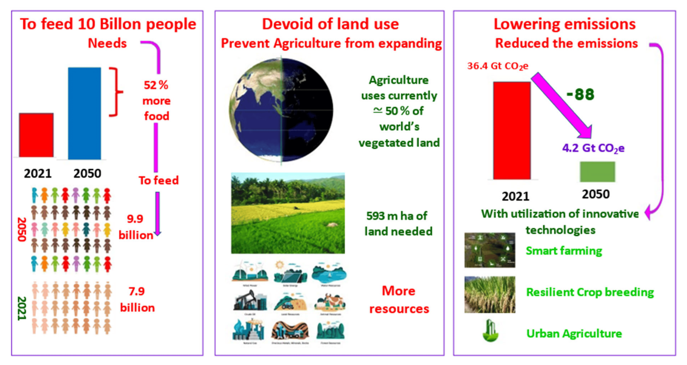In summary, the integration of deep learning and IoT in potato farming enhances the efficiency and sustainability of the cultivation process. It offers real-time, accurate detection of diseases and pests, leading to healthier crops, higher yields, and reduced labour and environmental costs. This innovative approach represents a significant advancement in the field of precision agriculture, offering a smarter, more efficient way to manage crop health and improve productivity.

**Fig 2:** image showing challenges in sustainable future

**Highlights:**

The integration of deep learning and IoT (Internet of Things) for automated disease detection and pest classification in potato farming involves several key features and components. Here are the primary key features of such a solution:

1. **IoT Devices and Sensors:**
   * **Environment Monitoring:** IoT sensors monitor environmental conditions such as temperature, humidity, soil moisture, and light intensity, which are crucial for disease prediction.
   * **Imaging Devices:** High-resolution cameras and drones capture images of potato plants regularly for real-time monitoring.
2. **Data Collection and Transmission:**
   * **Continuous Data Gathering:** IoT devices continuously collect data and transmit it to a central server or cloud storage.
   * **Wireless Communication:** Use of wireless technologies like Wi-Fi, Zigbee, or LoRaWAN for efficient data transmission.
3. **Deep Learning Models:**
   * **Image Processing:** Convolutional Neural Networks (CNNs) process the images to identify visual symptoms of diseases and pest infestations.
   * **Classification Algorithms:** Deep learning models classify the type of disease or pest based on patterns identified in the images.
4. **Real-time Analysis:**
   * **Immediate Detection:** The system provides real-time analysis and immediate detection of diseases and pests.
   * **Predictive Analytics:** Historical data and current environmental conditions are analyzed to predict potential outbreaks.
5. **Automated Alerts and Notifications:**
   * **Instant Alerts:** Farmers receive instant alerts via mobile apps or SMS when a disease or pest is detected.
   * **Actionable Insights:** Recommendations for treatments or preventive measures are provided alongside the alerts.
6. **User Interface and Dashboard:**
   * **Visual Dashboards:** User-friendly dashboards display the health status of the potato crops, environmental data, and alerts.
   * **Historical Data Visualization:** Visualization tools for tracking the progression of crop health over time.
7. **Integration with Farm Management Systems:**
   * **Seamless Integration:** The system can be integrated with existing farm management software for comprehensive farm oversight.
   * **Data Export:** Ability to export data for further analysis or reporting.
8. **Scalability and Flexibility:**
   * **Scalable Architecture:** The system can scale to accommodate larger farms or additional crop types.
   * **Customizable Models:** Models can be customized or retrained to detect new diseases or pests as they emerge.
9. **Remote Monitoring and Control:**
   * **Remote Access:** Farmers can monitor their fields remotely and take action without being physically present.
   * **Automated Control Systems:** Integration with automated irrigation and pest control systems for immediate response.
10. **Machine Learning and Data Science:**
    * **Continuous Learning:** The system improves over time by learning from new data and user feedback.
    * **Data Analytics:** Advanced analytics for deeper insights into crop health, pest behavior, and disease trends.

**Benefits**

* **Increased Efficiency:** Automated detection reduces the need for manual inspection, saving time and labor.
* **Early Detection:** Early identification of diseases and pests allows for timely intervention, minimizing crop damage.
* **Improved Yield:** Healthier crops lead to better yield and quality of produce.
* **Cost Savings:** Reduced need for pesticides and treatments due to precise targeting of affected areas.
* **Sustainability:** Promotes sustainable farming practices by reducing chemical usage and optimizing resource management.

These features collectively contribute to a robust and efficient solution for managing potato farming, ensuring healthier crops and higher productivity.

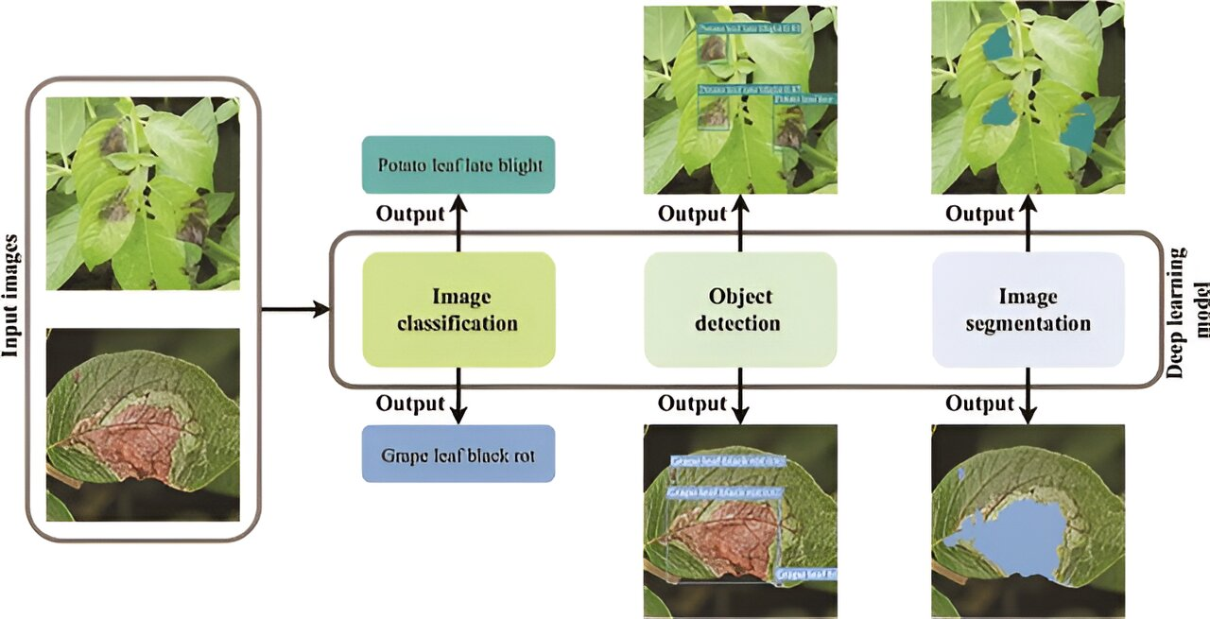

**Fig 3:** examples of plant disease diagnosis methods based on deep learning

1. **Literature survey:**

Kamilaris, A., & Prenafeta-Boldú, F. X. [1] conducted a comprehensive survey on the application of deep learning in agriculture, exploring its various uses and advancements. They highlighted the role of deep learning models in optimizing agricultural processes and improving yield prediction through data-driven insights. Their review emphasizes the potential of deep learning to revolutionize farming practices by enhancing efficiency and sustainability. Mohanty, S. P., Hughes, D. P., & Salathé, M. [2] focused on using deep learning specifically for image-based plant disease detection. Their research in Frontiers in Plant Science demonstrated how convolutional neural networks (CNNs) can accurately identify diseases from visual cues, aiding in early detection and prompt treatment, thereby minimizing crop losses and optimizing plant health management strategies. Liakos, K. G., Busato, P., Moshou, D., Pearson, S., & Bochtis, D. [3] provided a detailed review of machine learning applications in agriculture, published in Sensors. They discussed how machine learning algorithms are leveraged across various agricultural domains, from precision farming to crop monitoring, highlighting their role in optimizing resource allocation and improving decision-making processes in farming operations. Rathore, M. M., Son, N. T., & Park, J. H. [4] explored IoT-based big data applications in smart city planning, extending towards super city planning. Their study in the International Journal of Smart Home discussed how IoT-enabled data analytics can revolutionize urban agriculture and food supply chain management, contributing to sustainable urban development practices. Verdouw, C. N., Wolfert, J., Beulens, A. J. M., & Rialland, A. [5] examined the virtualization of food supply chains using IoT technologies, as published in the Journal of Food Engineering. Their research emphasized how IoT facilitates real-time monitoring and management of food supply networks, ensuring quality control, traceability, and efficiency in distribution channels. Wageningen University & Research [6] contributed to the advancement of smart farming practices through IoT-based applications. Their research focuses on integrating IoT sensors and data analytics to enhance agricultural productivity, optimize resource utilization, and mitigate environmental impact, thus promoting sustainable farming practices globally. University of California, Davis [7] investigated automated disease detection using drones in agriculture, highlighting the potential of aerial surveillance and remote sensing technologies to monitor crop health efficiently. Their work underscores how drones equipped with advanced imaging technologies can detect diseases early, enabling timely intervention and reducing crop losses. Kamilaris, A., & Prenafeta-Boldú, F. X. [8] revisited deep learning applications in agriculture, reinforcing their earlier findings on the transformative impact of deep learning models. Their study in Computers and Electronics in Agriculture reiterated the potential of AI-driven solutions to revolutionize crop management practices and improve agricultural sustainability. Tsouros, D. C., Bibi, S., & Sarigiannidis, P. [9] focused on early pest detection in greenhouses using IoT technologies. Their research in Sensors highlighted how IoT-enabled sensor networks can detect pest infestations promptly, allowing farmers to implement targeted pest control measures and reduce reliance on chemical pesticides, thereby promoting eco-friendly farming practices. Wolfert, S., Ge, L., Verdouw, C., & Bogaardt, M. J. [10] conducted a review on big data applications in smart farming, emphasizing the integration of data analytics to optimize agricultural operations. Their study in Agricultural Systems discussed how big data analytics can enhance decision-making in precision farming, improve crop yield predictions, and optimize resource management for sustainable agriculture. Commonwealth Scientific and Industrial Research Organisation (CSIRO) [11] focused on precision agriculture using IoT sensors, emphasizing how IoT technologies enhance data-driven decision-making in farming practices, from soil monitoring to crop management, thereby optimizing resource use and improving agricultural productivity. Brahimi, M., Arsenovic, M., Laraba, S., Sladojevic, S., Boukhalfa, K., & Moussaoui, A. [12] explored deep learning applications for plant diseases, particularly in detection and saliency map visualization. Their research in Computers and Electronics in Agriculture highlighted how deep learning models can accurately identify and classify plant diseases based on visual symptoms, aiding in early intervention and effective disease management. Indian Agricultural Research Institute (IARI) [13] contributed to smart irrigation systems in Indian agriculture, emphasizing the use of IoT technologies to optimize water use efficiency. Their research focuses on integrating IoT-enabled sensors and data analytics to monitor soil moisture levels and automate irrigation schedules, ensuring optimal crop growth while conserving water resources. Ramcharan, A., Baranowski, K., McCloskey, P., Ahmed, B., Legg, J., & Hughes, D. P. [14] conducted research on deep learning for image-based cassava disease detection. Published in Frontiers in Plant Science, their work demonstrated how deep learning algorithms can detect diseases in cassava plants from images, enabling early detection and timely disease management to mitigate crop losses. Volcani Center [15] developed an automated greenhouse management system in Israel, utilizing IoT technologies to monitor and control environmental parameters. Their research focused on optimizing greenhouse conditions for crop growth and productivity through real-time data monitoring and automated control systems. Ray, P. P. [16] discussed IoT applications for smart agriculture, exploring technologies, practices, and future directions in enhancing agricultural productivity. Published in the Journal of Ambient Intelligence and Smart Environments, their review highlighted how IoT-enabled solutions can revolutionize farming practices by providing real-time data analytics and decision support for farmers. Mahlein, A. K. [17] reviewed plant disease detection using imaging sensors, focusing on the specific demands and challenges in precision agriculture and plant phenotyping. Their research in Advances in Agronomy emphasized the role of imaging technologies in monitoring and managing plant health, facilitating early disease detection and targeted treatment strategies. Zhejiang University [18] researched the use of UAVs for crop monitoring in China, leveraging aerial surveillance and remote sensing technologies. Published in Computers and Electronics in Agriculture, their study explored how UAVs equipped with advanced sensors can capture high-resolution images to monitor crop growth, detect anomalies, and optimize farming practices. Dyrmann, M., Jørgensen, R. N., & Midtiby, H. S. [19] compared methods for weed detection in sugar beet fields based on sensor fusion. Their research in Computers and Electronics in Agriculture evaluated the effectiveness of sensor fusion techniques in accurately detecting and distinguishing weeds from crops, aiming to reduce herbicide use and enhance weed management strategies. Brazilian Agricultural Research Corporation (Embrapa) [20] implemented IoT-based livestock monitoring in Brazil, focusing on improving animal welfare and productivity through real-time data monitoring and analytics. Their research highlighted how IoT technologies can enhance livestock management practices, from health monitoring to environmental control. Zhang, Q., Wu, J., & Li, Q. [21] reviewed precision agriculture technologies and practices, emphasizing the integration of IoT, data analytics, and machine learning in optimizing agricultural operations. Published in IEEE Access, their study explored how these technologies enable precision farming practices, enhancing crop productivity and sustainability. University of British Columbia [22] conducted research on soil health monitoring using IoT sensors in Canada. Their study focused on deploying IoT-enabled sensors to monitor soil parameters such as moisture levels and nutrient content, providing farmers with actionable insights to optimize soil management practices and improve crop yields. McCulloch, M., Heath, R., & Hammond, L. [23] discussed the application of artificial intelligence in agriculture, exploring its potential to revolutionize farming practices. Published in Agricultural Systems, their research highlighted how AI technologies, from machine learning to computer vision, can optimize agricultural processes, improve decision-making, and address global food security challenges. Fraunhofer Institute for Industrial Engineering IAO [24] developed an IoT-enabled pest management system in Germany, utilizing real-time data monitoring and analytics to detect and mitigate pest infestations. Their research focused on integrating IoT technologies into pest management strategies, enhancing crop protection and reducing reliance on chemical pesticides. Kang, Y., & Othman, M. [25] explored IoT and machine learning applications for crop management in their study published in IEEE Internet of Things Journal. They highlighted how IoT-enabled sensor networks and machine learning algorithms can optimize crop growth conditions, improve resource use efficiency, and maximize agricultural productivity. Tokyo University of Agriculture and Technology [26] implemented IoT in aquaponics systems in Japan, leveraging IoT technologies to monitor and manage aquaponics environments. Their research focused on optimizing fish and plant production through real-time data monitoring, automated control systems, and predictive analytics, ensuring sustainable aquaponics operations. Jawad, H. M., Nordin, R., Gharghan, S. K., Jawad, A. M., & Ismail, M. [27] reviewed energy-efficient wireless sensor networks for precision agriculture. Published in Sensors, their research explored the design and implementation of wireless sensor networks (WSNs) to monitor environmental parameters in agriculture, optimizing resource use and enhancing farm productivity. University of Bologna [28] developed smart beehives using IoT in Italy, focusing on enhancing beekeeping practices and honey production through IoT-enabled hive monitoring. Their research highlighted how IoT technologies can monitor hive conditions, track bee behavior, and improve bee health, thereby supporting sustainable beekeeping practices. Deval, P. H., Mulani, H. H., & Lahane, S. P. [29] surveyed IoT applications in agriculture, discussing applications, technologies, and challenges in integrating IoT into farming practices. Published in Computers and Electronics in Agriculture, their review explored how IoT technologies enable precision farming, from real-time data monitoring to automated decision-making. University of Reading [30] utilized remote sensing for precision agriculture in the UK, focusing on using satellite imagery and drone technology to monitor crop health and optimize farming practices. Their research emphasized how remote sensing technologies can provide farmers with valuable insights into crop growth, pest infestations, and environmental conditions.

Apat, S. K., Mishra, J., Raju, S. K., & Padhy, N. [31] investigated IoT-assisted crop monitoring using machine learning algorithms for smart farming. Published in the book "Next Generation of Internet of Things," their study explored how IoT sensors and machine learning models can predict crop yields, optimize irrigation schedules, and improve farm management practices. Yang, X., & Guo, T. [32] conducted research on machine learning applications in plant disease research, focusing on leveraging machine learning algorithms to identify disease-resistant genes and classify plant diseases accurately. Published in Machine Learning, their study highlighted how machine learning technologies improve disease management strategies in agriculture. Jawade, P. B., et al. [33] predicted disease outbreaks in mango crops using machine learning and IoT technologies. Published in Advances in Decision Sciences, their research demonstrated how machine learning models trained on IoT-collected data can forecast disease outbreaks, enabling farmers to implement preventive measures effectively. Akulwar, P. [34] proposed a recommender system for crop disease detection and yield prediction using machine learning approaches. Published in the book "Recommender System with Machine Learning and Artificial Intelligence," their study focused on developing a system to recommend disease management strategies based on crop health data and environmental factors. Medar, R., Rajpurohit, V. S., & Shweta, S. [35] predicted crop production in India using machine learning techniques, emphasizing the role of predictive modeling in optimizing agricultural productivity. Presented at the 5th International Conference on Convergence in Technology (I2CT), their research explored how machine learning algorithms can forecast crop yields and recommend fertilizer strategies for sustainable farming. Bondre, D. A., & Mahagaonkar, S. [37] developed models for predicting crop yield and recommending fertilizer applications using machine learning algorithms. Published in the International Journal of Engineering Applied Sciences and Technology, their research focused on optimizing crop production through data-driven insights and precision agriculture techniques. Kumar, Y. J. N., et al. [38] applied supervised machine learning approaches for crop yield prediction in the agriculture sector. Presented at the 5th International Conference on Communication and Electronics Systems (ICCES), their study demonstrated how supervised learning algorithms can analyze agricultural data to predict crop yields accurately, facilitating informed decision-making by farmers. Jain, A., et al. [39] reviewed plant leaf fungal diseases and their environmental speciation, focusing on understanding disease dynamics and environmental factors influencing fungal infections. Published in Bioengineered, their review highlighted the complex interactions between plants, pathogens, and environmental conditions in disease development. Kumari, P., et al. [40] predicted crop yield using SVM approach integrated with the E-MART system. Presented as an EasyChair Preprint, their study explored how SVM algorithms can analyze agricultural data to predict crop yields, integrating with the E-MART system for efficient farm management and decision support.

**3.** **Related Works**

There are different works by different scholars and researchers who had researched about such related topics and invented many possible ways to make farming and agricultural practice for farmers. Various Convolutional Neural Network (CNN) models which have been utilized to identify plant diseases and pest infestation are discussed. The first model that we will discuss is AlexNet (Antonellis et al., 2015), which is the CNN model developed in 2012. The AlexNet CNN win the classification challenge by achieving the highest accuracy using the 1000 classes Imagenet dataset. AlexNet is known for its high accuracy and speed, and it has been used for a variety of tasks, including plant disease detection. Another popular CNN model is VGG (Soliman et al., 2019), which was established in 2014 by the University of Oxford’s at Visual Geometry Lab. VGG is known for its high accuracy and is often used for image classification tasks. It has been employed to detect plant lesions by extracting hidden patterns from plant leaf data.

ResNet (Szymak et al., 2020), which was developed by Microsoft Research Asia in 2015, is known for its ability to handle very deep networks. It has been used for plant disease detection by using pre-trained ResNet models on the images of the plants. GoogLeNet (Wang et al., 2015), which was developed by Google in 2014, is known for its high accuracy and efficient use of computation resources. It has been used for plant disease detection by fine-tuning pre-trained GoogLeNet models on the images of the plants. InceptionV3, which was developed by Google in 2015, is known for its high accuracy and efficient use of computation resources. It has been used for plant disease detection by fine-tuning pre-trained InceptionV3 models on the images of the plants. DenseNet (Tahir et al., 2022), which was developed in the (Huang et al., 2017), is known for its ability to handle very deep networks and efficient use of computation resources. It has been used for plant disease detection by fine-tuning pre-trained DenseNet models on the images of the plants., ResNet is known for its ability to handle very deep networks.

This research article presents an architecture of Convolutional Neural Networks for determining the variety of crops from image sequences obtained from advanced agro-observation stations (Yalcin and Razavi, 2016). The authors address challenges related to lighting and image quality by implementing preprocessing steps. They then employ the CNN architecture to extract features from the images, highlighting the importance of the construction and depth of the CNN architecture in determining the recognition capability of the network. The accuracy of the model presented is evaluated to perform a comparison between the CNN model with those obtained using a support vector machine (SVM) classifier with the utilization of feature extractors such as Local Binary Patterns (LBP) and Gray-Level Co-Occurrence Matrix. The results of the approach are tested on a dataset collected through a government-supported project in Turkey, which includes over 1,200 agro-stations. The experimental outcomes affirm the efficiency of the suggested technique.

A novel meta-architecture is proposed, which utilizing a CNN designed for distinguishing between healthy and diseased plants (Fuentes et al., 2017b). The authors employed multiple characteristic extractors within the CNN to analyze input images that are divided into their corresponding categories. On the other hand, a CNN-based approach for the identification of various eight classes of rice viruses is presented in (Hasan et al., 2019). The authors performed features extraction using the features learning model and introduced them along with the corresponding labels into a support vector machine (SVM) linear multiclass model for training. The trained model achieved a validation accuracy of 97.5%.

A paper by Atila, Ümit presents an IoT-based framework for smart farming, incorporating drones and ground sensors to monitor crop health. The framework uses deep learning models to analyze images captured by drones and data collected from sensors to predict diseases in potato fields.Drones equipped with multispectral cameras provided high-resolution images, facilitating early disease detection. Deep learning models, particularly CNNs, were effective in identifying disease symptoms from drone images. The combination of aerial and ground-based data improved the accuracy of disease predictions, enabling proactive disease management.

**Different aspects that makes our project more Advanced :** Our section of the research focuses on the application of DL methods for segmentation plant lesions and pest infestation in botany and agriculture. With the increasing demand for food and the need for sustainable agricultural practices, the prompt identification and handling of illnesses affecting plants and pests is crucial for ensuring crop yields and maintaining the health of crops. DL, with its ability to process large amounts of data and its ability to learn from the data, has proven to be a robust tool for detecting plant diseases and pest infestation. In this section, we present a comprehensive overview of the state-of-the-art DL methods that have been developed for this purpose, including methods for image-based disease and pest detection, as well as methods for data-driven disease and pest detection using sensor data and other types of data. We also discuss the challenges and limitations of these methods and provide insights into future research directions. In particular, we will cover the recent advancements in DL for disease and pest detection, including the use of CNN, recurrent neural networks, and transfer learning techniques. These DL methods have shown to be effective in detecting plant diseases and pest infestation at a high level of accuracy, which can support farmers and agricultural professionals in taking appropriate action to prevent crop losses

**Higher Accuracy and Precision** makes deep learning way more preferable over AI and machine learning such as Complex Pattern Recognition,Deep learning models, especially convolutional neural networks (CNNs), are particularly adept at recognizing complex patterns in images. This makes them highly effective for detecting subtle signs of diseases and differentiating between various pests.**Feature Extraction** is also there Unlike traditional machine learning, which often requires manual feature extraction, deep learning models automatically learn the most relevant features from the data, leading to more accurate predictions.**Scalability and Adaptability** is another advantage of using deep learning in our project then Large Datasets Deep learning models perform better with large datasets, allowing them to scale effectively as more data becomes available.These models can be continually updated and retrained with new data, improving their performance over time.**Handling Diverse Data Types** is one of it's positive aspect (Multispectral and Hyperspectral Imaging)Deep learning can handle complex data types, such as multispectral and hyperspectral images, which provide more information than standard images and can improve disease and pest detection.Deep learning has the ability **Automation of Complex Tasks** it will automate the entire process from raw data input to prediction, reducing the need for human intervention and expertise..IoT is advantageous over AI and machine learning cause **Real-time Monitoring and Data** Collection feature they provide for example IoT devices such as sensors and cameras provide continuous, real-time monitoring of crops, allowing for immediate detection of issues and timely intervention.IoT devices can also collect a wide range of environmental data (e.g., temperature, humidity, soil moisture), which can be integrated into AI models to improve the accuracy of disease and pest detection.Enhanced ,it can provide **Proactive Alerts** IoT systems can provide real-time alerts to farmers about potential issues, enabling quicker decision-making and response,it will also give us **Continuous data collection** allows for the generation of insights and trends over time, helping farmers make informed decisions about crop management.

Farmers can monitor and manage their fields remotely using IoT devices, reducing the need for frequent physical inspections the only basic requirements are a wifi conecctions , a android app which will keep track of their crops and a camaera facilities such as drones which will monitor the crops 24/7.IoT can help optimize the use of resources (e.g., water, fertilizers) by providing precise data on crop needs, thereby reducing waste and improving efficiency .In summary, deep learning and IoT offer significant advantages over traditional AI and machine learning in disease detection and pest classification in farming. Their ability to provide real-time, accurate, and scalable solutions makes them highly valuable in modern precision agriculture.

# 

**4. Disease Detection**

**3.1 Types of Disease that affect potato farming**

3.1.1 **Bacterial wilt**

**Disease symptoms:**

1. In addition to the potato, the pathogen also damages plants such as chili, tomato, tobacco and egg plant, as well as several species of weeds.
2. The symptoms of bacterial wilt infection can be seen on all parts of infected plants.
3. Infected plant begins to wilt, starting from the tips of the leaves or where the stems branch out, and then spreading to all parts of the plant.
4. Leaves become yellow at their bases, then the whole plant wilts and dies. When stems are cut a brown colored ring will be visible.
5. When a tuber is cut in half, black or brown rings will, however, be visible. If left for a while or squeezed, these rings will exude a thick white fluid.
6. A further symptom is fluid coming out of tuber eyes. This can be signified by soil sticking to tuber eyes when crops are harvested. Serious infection causes tubers to rot.

**Survival and spread:**

* Bacterial wilt pathogen can survive in soil (without a host for several seasons), water, seed tubers, potato plant remnants.
* The disease can spread from field to field or from plant to plant within field via infected seed, air, water, soil, farming tools, livestock and people.

**Favourable conditions:**

* High temperature, soil moisture, low pH.
* The disease spread rapidly in the warmer temperatures in storage areas. Infected seed can also be a source of the disease in the field.

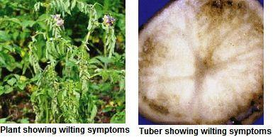

**Fig 6:** showing the damages of the plant because of bacterial wilt.

**3.1.2 Septoria leaf spot**

* **Disease symptoms:**

Less vigorous plants are usually affected

Small, round to irregular spots with a grey center and dark margin on leaves

Spots usually start on lower leaves and gradually advance upwards

At later stage spots coalesce and leaves are blighted

Complete defoliation of affected leaves may take place.

Stems and flowers are sometimes attacked

Fruits are rarely attacked

* **Survival and spread:**

Primary: Mycelium or conidia found in pycnidia in infected plant debris or on solanaceous weeds

Secondary: Conidia spread through rain splash or wind and also by slimy conidia sticking on to hands and clothing of potato pickers.

* **Favourable conditions:**

Poor vigour of plants due to nutrient deficiency in late season

High humidity or persistent dew at 25 ºC

Moist weather with intermittent showers.

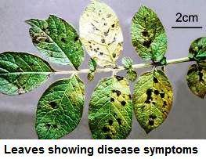

**Fig 7:** potato leaves effected by Septoria leaf spot 2.1.3 Late blight

* **Disease symptoms:**

This disease damages leaves, stems and tubers. Affected leaves appear blistered as if scalded by hot water and eventually rot and dry out.

When drying out, leaves turn brown or black in color. When infections are still active, spots appear on the underside of leaves blanketed in what looks like flour.

Affected stems begin to blacken from their tips, and eventually dry out.

Severe infections cause all foliage to rot, dry out and fall to the ground, stems to dry out and plants to die.

Affected tubers display dry brown-colored spots on their skins and flesh. This disease acts very quickly. If it is not controlled, infected plants will die within two or three days.

* **Survival and spread:**

The pathogen survives in plant debris in the soil.

It spreads through soil and infected seed tubers.

* **Favourable condition:**

High humidity

Low temperature and leaf wetness

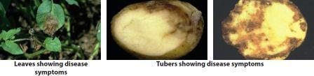

**Fig 8:** potato effected by Late blight

**3.2.4 Early blight**

* Disease symptoms:

This is a common disease of potato occurring on the foliage at any stage of the growth and causes characteristic leaf spots and blight.

Normally the disease symptoms become apparent during tuber bulking stage and develop leading to the harvest.

The early blight is first observed on the plants as small, black lesions mostly on the older foliage.

Spots enlarge, and by the time they are one-fourth inch in diameter or larger, concentric rings in a bull's eye pattern can be seen in the center of the diseased area.

Tissue surrounding the spots may turn yellow. If high temperature and humidity occur at this time, much of the foliage is killed.

Lesions on the stems are similar to those on leaves, sometimes girdling the plant if they occur near the soil line.

* Survival and spread:

Primary: The pathogen overwinters in infected plant debris in or on the soil where it can survive at least one and perhaps several years. It can also be seed borne.

Secondary: The spores are transported by water, wind, insects, other animals including man, and machinery.

* Favourable conditions:

Warm, rainy and wet weather

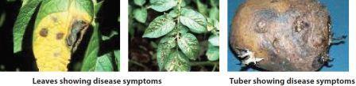

**Fig 9:** potato effected by Early blight

**3.1.4 Common scab**

* Disease symptoms:

Pathogen infects young developing tubers through the lenticels and occasionally through wounds.

Symptoms of common potato scab are quite variable and are manifested on the surface of the potato tuber. The disease forms several types of cork-like lesions including surface.

Damaged tubers have rough, cracked skin, with scab-like spots. Severe infections leave potato skins covered with rough black welts.

Initial infections result in superficial reddish-brown spots on the surface of tubers. As the tubers grow, lesions expand, becoming corky and necrotic.

* Survival and spread:

Pathogen can survive in soil, uncomposted manure or seed

It spreads through contaminated soil, seed and water.

* Favourable conditions:

Disease is common in fields with low soil pH favoured by high soil moisture. Disease problems may be aggravated by excessive irrigation.

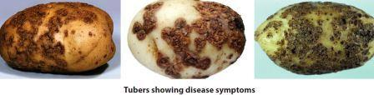

**Fig 10:** potato effected by Common scab

**3.1.6 Black scurf/ canker**

* Disease symptoms:

Rhizoctonia canker occurs when stolons contact soil borne fungal bodies.

Pathogen infects plant tissue and causes stolon blinding thus reducing tuber production and yield.

It also infects tubers causing black scurf but this is purely cosmetic, reduces tuber appearance and does not reduce yield.

* Survival and spread:

Pathogen is soil and seed borne, remain in soil and plant debris including infected tubers

* Favourable conditions:

High temperature and moisture is the favourable for disease development

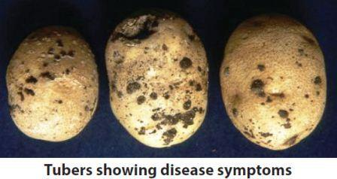

**Fig 11:** potato effected by Black scurf/ canker

**3.1.7 Viral disease (potato virus X, S, & Y)**

* **Disease symptoms:**

Potato virus Y (PVY ) is a Potyvirus, causes stipple streak. The necrotic strain generally causes mild foliage symptoms, but necrosis in the leaves of susceptible potato varieties.

Potato virus S (PVS) is a Carlavirus, if plant infected early in the season, show a slight deepening of the veins, rough leaves, more open growth, mild mottling, bronzing, or tiny necrotic spots on the leaves. PVS is transmitted by aphids non-persistently.

Potato virus X (PVX) is the type member of the Potyvirus family of plant viruses. Plants often do not exhibit symptoms, but the virus can cause symptoms of chlorosis, mosaic, decreased leaf size, and necrotic lesions in tubers.

PVX can interact with PVY and PVS to cause more severe symptoms and yield loss than either virus alone. The source of this virus is infected tubers.

* **Survival and spread:**

PVY is mechanical and aphid transmitted

PVS is transmitted by aphids, including Myzus persicae, the green peach aphid. It is also mechanically transmissible, and transmissible through tubers.

PVX is transmitted mechanically, not by an insect vector. Tobacco, pepper, and tomato can also serve as hosts of PVX.

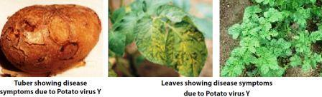

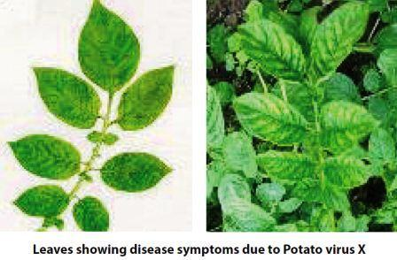

**Fig 12:** potato effected by **Viral disease (potato virus X, S, & Y)**

**3.1.8 Potato Spindle Tuber Viroid (PSTVd)**

* **Disease symptoms:**

It causes mild foliar symptoms including smaller leaves that curl downward, giving the plant a more upright growth habit. Plants can also be stunted, and leaves can be grey and distorted.

The stems are often more branched, with the branches having sharp angles on the stem.

Tubers become narrow and spindle or oblong in shape, or more rounded than expected for a particular variety, and have prominent eyebrows.

Tubers can also become cracked or develop knobs and swellings.

* **Survival and spread:**

The PSTVd often transmitted mechanically, as well as through pollen and true seed.

PSTVd can also infect tomato and nightshade.

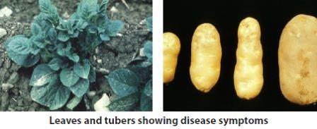

**Fig 13:** potato effected by Spindle Tuber Viroid (PSTVd)

**3.1.9 Black leg and soft rot**

* **Disease symptoms:**

Black leg is a rot of the lower stem region. This is encouraged by cool, damp conditions.

Soft rot occurs when the bacteria gains access to the tuber through wounds & other entry points.

Symptom can range from cultivator damage to fungal lesions.

The bacteria dissolve the cell walls and liquefy the tuber invards. No distinct smell is present in true soft rot.

* **Survival and spread:**

The introduction of bacteria is always through a wound in the plant tissue. It can reside in plant residue for short periods. The pathogen may spread through the soil water and infected seed.

* **Favourable conditions:**

Disease is encouraged by cool, humid conditions.

#### https://static.vikaspedia.in/media/images_en/agriculture/crop-production/integrated-pest-managment/ipm-for-vegetables/ipm-strategies-for-potato/softrotimg.jpg

**Fig 14:** potato effected by black leg and soft rot

**3.1.10 Pink rot**

* **Disease symptoms:**

Foliar symptoms of underground infections include wilting and chlorosis.

Tubers become infected through diseased stolons and show darkened diseased area on the skin.

The rotted tissues remain firm and become slightly spongy.

If the tuber is cut the tissue oxidizes to a pinkish tinge, an easy diagnostic characteristic.

* **Survival and spread:**

Soil and seed borne.

* **Favourable conditions:**

High soil moisture and cool condition increase disease incidence.

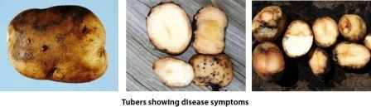

**Fig 15**: potato effected by pink rot

**3.1.11 Black heart- disorder**

* **Disease symptoms:**

Black heart occurs primarily in storage when the tubers do not receive enough oxygen.

Blackening of the tuber center follows acute oxygen deficiency associated with either low temperature in confined storage or high field soil temperatures

The tissue dies from the inside out and turns jet black. Smell is absent.

Affected tubers rot later.

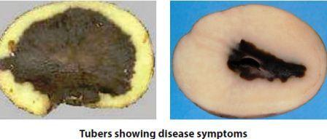

**Fig 16:** potato effected by black heart disorder

5. Technological Approaches and Methods

In agricultural practices, the effective management of diseases and pests is crucial for maximizing crop yield and quality. Various methods have been employed, ranging from traditional organic chemical applications to modern technological solutions. These include the strategic use of herbicides, fungicides, and pesticides, aimed at controlling pests and diseases at their early stages to minimize crop losses.

Technological advancements have significantly enhanced disease and pest monitoring in agriculture.

**4.1 Crop health-monitoring sensors**

Sensors have emerged as vital tools, enabling real-time monitoring of plant conditions. These sensors form the backbone of ground-based systems designed to detect diseases through spectroscopic and volatile profiling methods. Such systems provide rapid and reliable data, aiding in timely interventions to protect crop health.

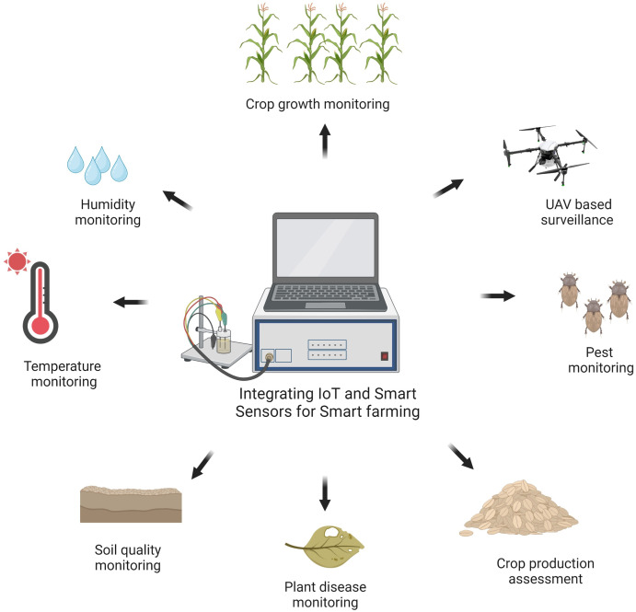

**Fig 17 :** example of Iot and monitoring sensors for smart farming

**4.1.1.** **Optical Sensors**

Optical sensors, on the contrary, use light reﬂection to measure and record crop and soil data in real-time crops. These crop reﬂectance sensors typically operate near oT-Assisted Crop Monitoring Using Machine Learning Algorithms.

Infrared visible regions of the spectrum and calculate vegetation indices at least by integrating 02 wavelengths. The visible light has a direct association with the chlorophyll concentration from an agronomic standpoint, absorbing red and blue light while reﬂecting green light. That is why we see healthy plants as green. Electrochemical Sensors are a type of sensor that uses electricity to detect a chemical reaction. RVI is the relationship between these two wavelengths (Ratio Vegetation Index). The NDVI(Natural Difference Value Index) is a Normalized Difference Vegetation Index and the suggested normalization ensures that the NDVI values are contained in the same scale of values, ranging from −1 to 1, as indicated in the equation.

NDVI = (ρIR−ρV)/(ρIR+ρV)

where ρIR represent infrared reﬂectance;

and ρV is visible reﬂectance.

This sensor provides the status required for precision agriculture.

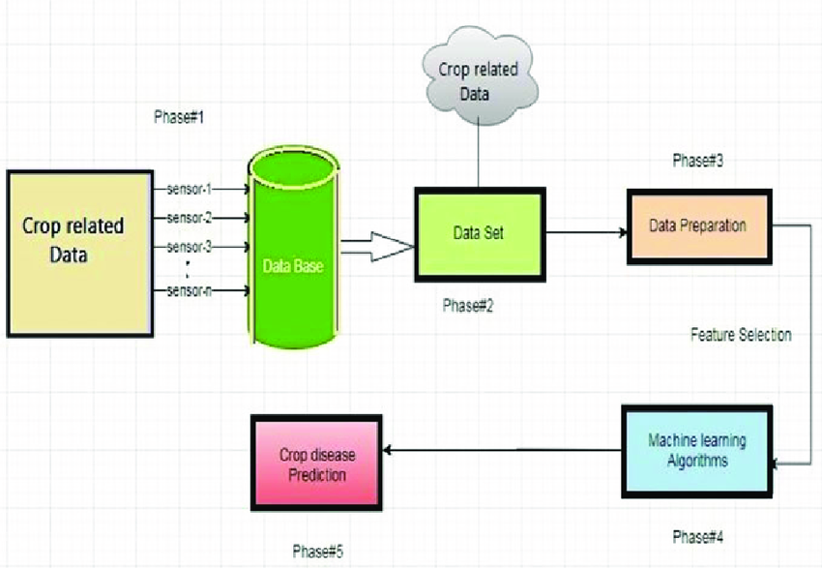**Fig 18**: FF Model

**4.1.2 HTE MIX Sensors:**

It is utilized to provide moisture content and temperature in the soil as well as the surrounding environment. It is a typical environment parameter that pops up on a regular basis, and its handling is crucial in various domains. It is an electric capacity sensor that connects to a Smart Soil Moisture Sensor’s cell.

**4.1.3 Motion Detector Sensors:**

All across the ﬁeld, motion sensors are used. When the recordings are made around the camp, those sensors can do a server-to-server transaction and then send a message to each other tool when the data is processed, all while remaining within the farm’s boundaries. This device can also be used to make noise to scare animals away from potentially hazardous crops or plant.

**Phase#2**: During this phase, the heterogeneous data collected from different sensors were ﬁltered and made ready for feature selections.

**Phase#3**: The process of decreasing no. of input variable(s) during the development process of a predictive model is said to be as feature selection. Its primary goal is to minimize the number of input variables in order to reduce overall modelling costs, and in some cases, it is used to improve performance.

Phase#4:

The following ML algorithms were applied to the selected features to compare and

predict the disease affected to the selected crops.

Phase#5:

Most likely disease will be predicted for the selected crops, and necessary precaution

may be taken to avoid major ﬁnancial loss to the farme

Phase#4:

The following ML algorithms were applied to the selected features to compare and

predict the disease affected to the selected crops.

Phase#5:

Most likely disease will be predicted for the selected crops, and necessary precaution

may be taken to avoid major ﬁnancial loss to the farme

**Phase#4**: The following ML algorithms were applied to the selected features to compare and predict the disease affected to the selected crops.

**Phase#5**: Most likely disease will be predicted for the selected crops, and necessary precaution may be taken to avoid major ﬁnancial loss to the farmer.

**4.2 Image Pre-processing**

Image processing play pivotal roles in modern disease detection strategies. Techniques such as RNA analysis, nucleic acid probes, and microscopy are utilized for precise diagnostics of plant diseases. Additionally, color feature extraction using models like YCbCr, HSL, and CIELB enhances the accuracy of identifying disease symptoms in crop imagery. Shape and texture analysis further complement these methods, helping differentiate healthy from diseased plant tissues with high accuracy. For instance, shape extraction techniques have been successfully applied to detect diseases in sugarcane and maize leaves.

Certain steps of Image Pre-processing in the field of agriculture are mentioned below for better understanding

4.2.1 **Image Acquisition:**

***Capture High-Quality Images*** ensure IoT devices such as cameras or multispectral sensors capture clear and detailed images of potato plants, including leaves, stems, and surrounding areas.

4.2.2 **Noise Reduction and Cleaning:**

***Noise Removal*** use filters (e.g., Gaussian blur, median filter) to remove sensor noise caused by varying lighting conditions, weather, or hardware imperfections.

***Artifact Removal*** address artifacts like lens distortion or motion blur that may obscure important details in the images.

4.2.3 **Normalization and Standardization:**

***Pixel Normalization*** scales pixel values to a consistent range (e.g., [0, 1] or [-1, 1]) to ensure uniformity across all images.

***Color Standardization*** adjusts color balance and intensity to account for differences in lighting and sensor characteristics across images.

4.2.4 **Image Enhancement:**

***Contrast Adjustment*** enhances contrast to improve visibility of subtle details, such as disease symptoms or pest markings on potato plants.

***Sharpening*** applies sharpening techniques to clarify edges and enhance image clarity, aiding in the identification of fine details.

4.2.5 **Image Segmentation and Region of Interest (ROI) Extraction:**

***Segmentation*** separates potato plant parts (e.g., leaves, stems) from the background using segmentation algorithms to focus analysis on relevant areas.

***ROI Extraction***  define and extract ROIs containing disease lesions or pest clusters for targeted analysis and classification.

* 1. **6 Data Augmentation:**

***Generate Augmented Data*** increase dataset diversity by applying transformations such as rotation, flipping, scaling, and shearing.

***Simulation of Environmental Variability*** introduce variations in lighting, weather conditions, and perspectives to improve model robustness and generalization.

* + 1. **Feature Extraction:**

***Extract Relevant Features*** use techniques like texture analysis, edge detection, and blob detection to extract discriminative features related to disease symptoms (e.g., spots, discoloration) and pest characteristics (e.g., shape, size).

***Dimensionality Reduction*** apply methods like Principal Component Analysis (PCA) or feature selection algorithms to reduce the dimensionality of feature vectors while retaining essential information.

* + 1. D**ata Labeling and Annotation:**

***Annotation of Labels*** manually or automatically annotate images with labels indicating the presence or absence of specific diseases (e.g., late blight, early blight) and pests (e.g., aphids, mites).

***Bounding Boxes or Masks*** create bounding boxes or masks to precisely localize and identify disease areas or pest clusters within potato plant images.

* 1. **Artificial Intelligence (AI)**

Artificial Intelligence techniques have revolutionized pest and disease classification. Algorithms like feed-forward neural networks and Particle Swarm Optimization (PSO) are employed to process vast amounts of data and extract relevant features for accurate identification of pest species and disease types. Support Vector Machines (SVMs) are also utilized for their ability to classify diseases in crops like vegetables and sugar beets, achieving classification accuracies ranging from 65% to 90%.

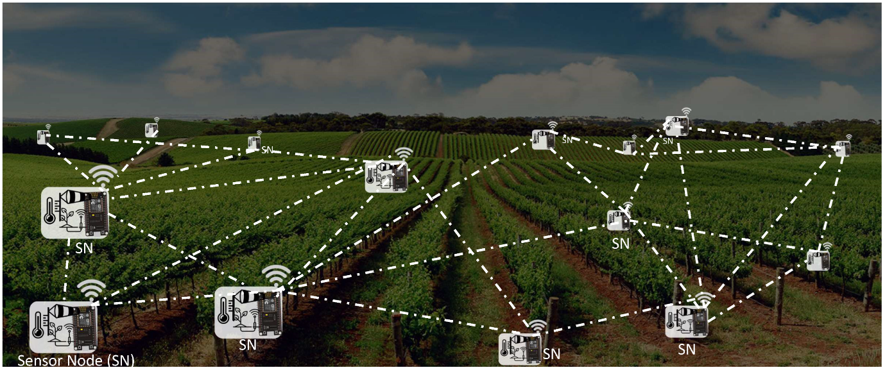

**Fig 19:** Sample example presentation of wireless sensor

Deep learning methodologies have further advanced disease detection capabilities in agriculture. Models such as Fast R-CNN and VGGNet are used to build robust classification systems for identifying diseases in tomato plants with high accuracy. Attention Embedded Residual Networks and Multi-Context Fusion Networks (MCFN) have also demonstrated significant success rates in detecting various crop diseases, showcasing their potential in achieving accuracies as high as 97.5% across diverse datasets.

Despite these advancements, challenges remain, particularly in rural areas with limited network connectivity. In response, innovative solutions have emerged, such as lightweight deep learning models optimized for smart devices. These models enable offline disease and pest detection capabilities directly on farmer-accessible Android platforms, circumventing the need for continuous internet access.

The integration of advanced technologies in agriculture, including AI, deep learning, and sensor networks, represents a paradigm shift in disease and pest management. These innovations not only enhance productivity by ensuring early detection and targeted treatment but also promote sustainable farming practices by minimizing chemical usage. As research continues to evolve, further advancements in technology promise to revolutionize how farmers monitor and safeguard crop health, ensuring food security and sustainability in the face of evolving agricultural challenges.

Another important aspect is the ethical and environmental considerations of using AI in agriculture. Reducing chemical usage through precise targeting of treatments can lower the environmental impact, preserving biodiversity and soil health. Furthermore, ethical use of AI involves ensuring that technologies are accessible to small-scale farmers, not just large agribusinesses, promoting equity in agricultural advancements.

Additionally, the deployment of AI technologies must consider data privacy and the security of sensitive agricultural information. Protecting farmers' data from misuse and ensuring transparency in AI decision-making processes are essential for building trust and encouraging widespread adoption. Environmentally, AI-driven precision agriculture supports the conservation of water and other resources by optimizing irrigation and fertilization practices, leading to more sustainable farming ecosystems. These ethical and environmental considerations are paramount in developing responsible AI applications that benefit both farmers and the broader ecosystem.

In conclusion, AI, when combined with IoT and other technological advancements, offers a powerful tool for enhancing disease detection and pest classification in potato farming. It provides real-time monitoring, precise diagnostics, and predictive analytics, which are essential for sustainable and efficient agricultural practices.

6. Cloud Computing and Big Data Analytics

**5.1** **Scalable Storage and Processing:**

Cloud platforms offer scalable storage and powerful computational resources for analyzing large volumes of data collected from IoT devices. This capability is essential for handling the massive amounts of data generated by modern agricultural practices, including sensor readings, satellite images, and weather data. Cloud computing enables the processing and analysis of this data at scale, providing actionable insights that can improve crop management decisions.

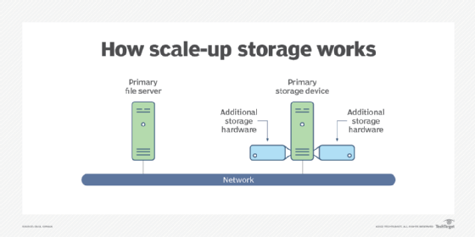

**Fig 20:** Image showing Scaling storage method.

In agriculture, the ability to store and process vast amounts of data is crucial for several reasons. First, farms generate extensive data through IoT sensors that monitor soil conditions, weather patterns, crop health, and machinery performance. This data, when aggregated and analyzed, can reveal patterns and trends that help optimize planting schedules, irrigation strategies, and fertilizer applications. Cloud-based storage ensures that this data is securely stored and readily accessible, even in remote farming locations where local infrastructure may be limited.

**5.2** **Machine Learning Pipelines:**

Cloud-based tools facilitate the development, training, and deployment of machine learning models, including deep learning algorithms used for image recognition and predictive analytics in agriculture. Machine learning pipelines in the cloud streamline the process from data preprocessing to model deployment, making it accessible to agricultural researchers and practitioners without extensive programming or computational expertise.

These pipelines are particularly beneficial for developing predictive models that forecast crop yields, detect diseases early, and optimize resource allocation based on real-time data inputs. For example, researchers can use historical crop yield data, combined with current weather forecasts and soil quality measurements, to predict optimal planting times and crop varieties for maximum yield. By leveraging cloud-based machine learning, farmers can make data-driven decisions that lead to improved productivity and sustainability.

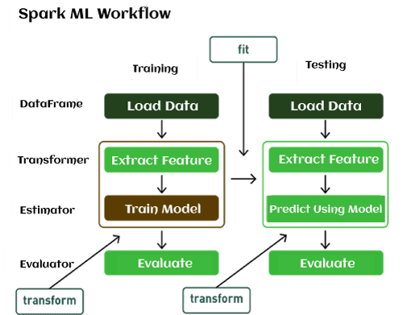

**Fig 21:** Visual Example of Machine Learning Pipelines.

**5.3** **Real-time Data Analysis:**

Real-time data analysis capabilities offered by cloud computing and big data analytics are transforming agriculture by enabling immediate responses to dynamic field conditions. IoT devices equipped with sensors continuously monitor soil moisture levels, temperature variations, and pest infestations. Cloud-based analytics process this data in real-time, allowing farmers to receive alerts and recommendations for timely interventions, such as adjusting irrigation schedules or applying targeted pesticide treatments.

This capability is particularly critical in disease and pest management, where early detection and rapid response can prevent widespread crop damage. For instance, sensors detecting abnormal humidity levels or sudden temperature changes can trigger automated alerts, prompting farmers to investigate potential disease outbreaks or pest infestations before they escalate. By intervening early, farmers can mitigate losses and reduce the need for reactive, broad-spectrum chemical treatments.

**5.4** **Integration with Other Technologies:**

Cloud computing and big data analytics integrate seamlessly with other advanced agricultural technologies, such as AI and IoT, to create a synergistic ecosystem for precision farming. AI algorithms trained on large datasets can analyze complex relationships between environmental factors and crop health, providing insights that inform decision-making at every stage of the agricultural cycle.

For example, AI-powered drones equipped with multispectral cameras capture high-resolution images of fields, which are then processed in the cloud to identify crop stress, nutrient deficiencies, or early signs of disease. This integrated approach allows farmers to take targeted actions, such as adjusting fertilizer applications or implementing crop rotation strategies, based on data-driven recommendations.

Furthermore, the integration of IoT devices with cloud-based analytics enables the development of smart irrigation systems that adjust water delivery based on real-time soil moisture data. By optimizing water usage, farmers can conserve resources while maximizing crop yields, contributing to sustainable agricultural practices.

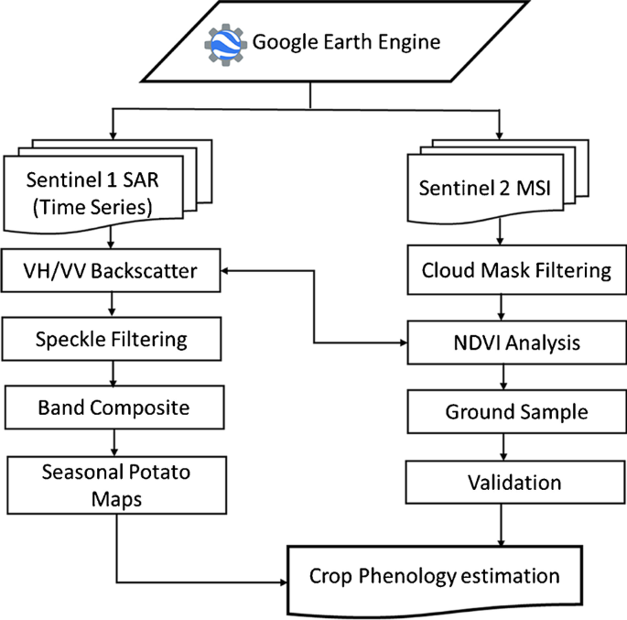

**Fig20:** Sample flowchart of Monitoring of potato crop using cloud computing

**5.5** **Cost-effectiveness:**

The cost-effectiveness of cloud computing in agriculture lies in its pay-as-you-go model, which eliminates the need for upfront investments in expensive hardware and software infrastructure. Small and medium-sized farms, which may lack the financial resources for large-scale IT investments, can access sophisticated analytics and computational power through cloud service providers.

Moreover, cloud-based solutions reduce operational costs associated with data management and maintenance. Farms can scale their computing resources up or down based on seasonal demands, paying only for the resources they use. This flexibility allows agricultural enterprises to allocate resources more efficiently, focusing on innovation and productivity enhancements rather than IT infrastructure management.

**5.6** **Security and Data Privacy:**

Ensuring the security and privacy of agricultural data stored and processed in the cloud is paramount. Cloud service providers employ robust security measures, such as encryption, authentication mechanisms, and regular audits, to protect sensitive agricultural information from unauthorized access and cyber threats.

Data privacy regulations, such as the General Data Protection Regulation (GDPR) in Europe and similar laws globally, impose strict guidelines on the collection, storage, and use of personal and agricultural data. Compliance with these regulations is essential for maintaining trust among farmers and stakeholders in cloud-based agricultural solutions.

**5.7 Environmental Impact:**

Cloud computing and big data analytics in agriculture contribute to environmental sustainability by optimizing resource use and reducing environmental footprint. Precision farming techniques enabled by cloud-based analytics minimize the use of water, fertilizers, and pesticides through targeted applications based on real-time data insights.

For example, predictive models that forecast weather patterns and soil moisture levels help farmers optimize irrigation schedules, reducing water consumption and runoff. Similarly, AI-driven pest management systems can identify and target specific pest species, minimizing the need for broad-spectrum pesticides that can harm beneficial insects and soil health.

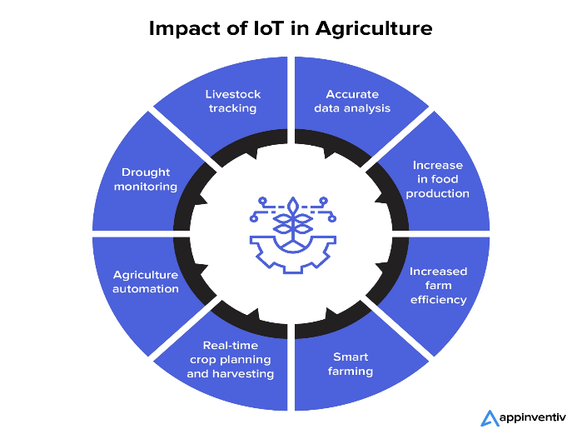

**Fig 21:** Example chart of Environmental Impact

**5.8 Future Directions and Innovation:**

The future of cloud computing and big data analytics in agriculture is promising, with ongoing advancements in AI, machine learning, and IoT technologies. Innovations such as edge computing, which processes data closer to the source (e.g., IoT devices in the field), promise to reduce latency and enable faster decision-making in remote agricultural areas with limited connectivity.

Furthermore, the integration of blockchain technology with cloud-based agriculture systems holds potential for enhancing transparency and traceability in food supply chains. Blockchain can securely record agricultural transactions, from seed sourcing to distribution, ensuring food safety and authenticity while fostering trust among consumers and stakeholders.

In conclusion, cloud computing and big data analytics represent transformative technologies that empower farmers with actionable insights, improve decision-making, and enhance sustainability in agriculture. By leveraging these technologies, agricultural enterprises can achieve higher productivity, reduce operational

costs, and contribute to global food security in a resource-efficient manner.

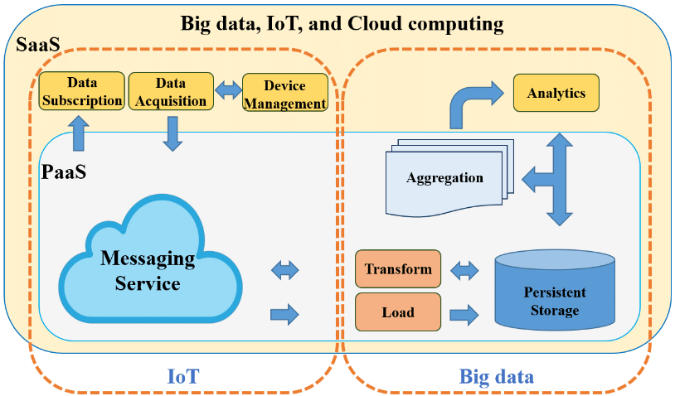

**Fig 22:** Example of Cloud Computing and Big Data Analytic

7. Edge Computing in Agriculture:

In recent years, agriculture has witnessed a transformative shift towards adopting advanced technologies to improve productivity, optimize resource use, and enhance sustainability. One such technology that has gained significant traction is edge computing. Edge computing involves processing data closer to the source of generation, typically at or near the edge of the network, rather than relying on centralized cloud servers. This approach is particularly advantageous in agriculture, where real-time data processing and immediate decision-making can significantly impact crop yield, resource efficiency, and overall farm management.

**6.1** **Understanding Edge Computing in Agriculture:**

Edge computing in agriculture revolves around the concept of local data processing and real-time analytics at the point of data generation—on farm equipment, IoT sensors, or other field devices. The primary goal is to reduce latency, improve responsiveness, and minimize the reliance on continuous internet connectivity, which is often limited in rural farming areas. By processing data locally, edge computing enables faster decision-making and timely interventions, crucial for optimizing farming operations.

**6.2 Components of Edge Computing in Agriculture:**

**6.2.1. Local Data Processing:**

At the core of edge computing in agriculture is local data processing. IoT devices embedded in farming equipment, such as soil moisture sensors, weather stations, and crop monitoring cameras, collect vast amounts of data throughout the agricultural cycle. Edge computing allows these devices to analyze data on-site, identifying patterns, anomalies, or critical events in real-time. For example, sensors can detect sudden changes in soil moisture levels, indicating potential irrigation needs, without waiting for data to travel to distant servers.

**6.2.2. IoT Gateways:**

IoT gateways act as intermediaries between edge devices and centralized cloud servers. These gateways aggregate, preprocess, and filter data before transmitting relevant information to the cloud for further analysis. In agriculture, IoT gateways play a vital role in optimizing data transmission, reducing bandwidth usage, and ensuring that only essential data is sent for cloud-based analytics. This approach not only conserves network resources but also enhances data security by minimizing exposure to external threats.

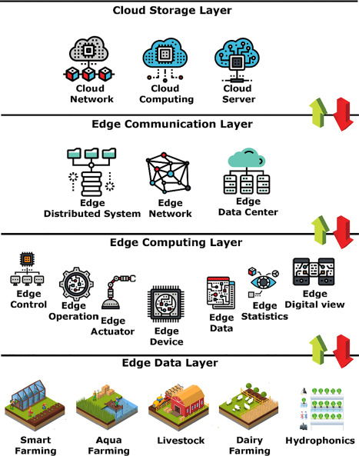

**Fig 23:** Diagram of framework of edge computing in agriculture.

**6.3** **Applications of Edge Computing in Agriculture:**

**6.3.1. Precision Irrigation:**

Edge computing facilitates precision irrigation by analyzing real-time data from soil moisture sensors and weather forecasts. By processing data locally, irrigation systems can adjust water delivery rates based on immediate crop needs and environmental conditions. This capability minimizes water wastage, improves crop water use efficiency, and ensures optimal soil moisture levels for plant growth, particularly in regions prone to water scarcity.

**6.3.2. Pest and Disease Monitoring:**

Early detection of pests and diseases is critical for preventing crop losses and minimizing the use of chemical pesticides. Edge computing enables IoT devices equipped with image recognition and AI algorithms to detect signs of pests or diseases directly in the field. For instance, cameras installed in orchards can identify pest infestations or disease symptoms on fruit trees, triggering immediate responses such as targeted spraying or biological control measures.

**6.3.3. Livestock Monitoring and Management:**

In animal agriculture, edge computing supports real-time monitoring of livestock health and behavior. Wearable sensors or tags collect data on physiological parameters such as heart rate, body temperature, and feeding behavior. Edge devices analyze this data locally to detect signs of illness, stress, or abnormal behavior, enabling prompt veterinary intervention and improving overall herd management practices.

**6.4 Benefits of Edge Computing in Agriculture**

**6.4.1. Enhanced Real-Time Decision-Making:**

By processing data locally, edge computing reduces latency and enables farmers to make informed decisions in real-time. This capability is crucial for responding promptly to changing field conditions, weather events, or pest outbreaks, thereby optimizing agricultural operations and maximizing crop yield.

**6.4.2. Improved Data Privacy and Security:**

Edge computing enhances data privacy and security by minimizing the transmission of sensitive agricultural data over external networks. Data is processed and stored locally, reducing the risk of unauthorized access or cyber threats associated with cloud-based storage solutions. This approach aligns with regulatory requirements and strengthens trust among farmers and stakeholders in adopting digital technologies.

**6.4.3.** **Cost-Efficiency and Scalability:**

Edge computing offers cost-effective solutions for small to medium-sized farms by reducing dependency on expensive cloud infrastructure and internet connectivity. Localized data processing minimizes operational costs associated with data transmission and storage, while scalability allows farmers to expand edge computing capabilities as their operations grow.

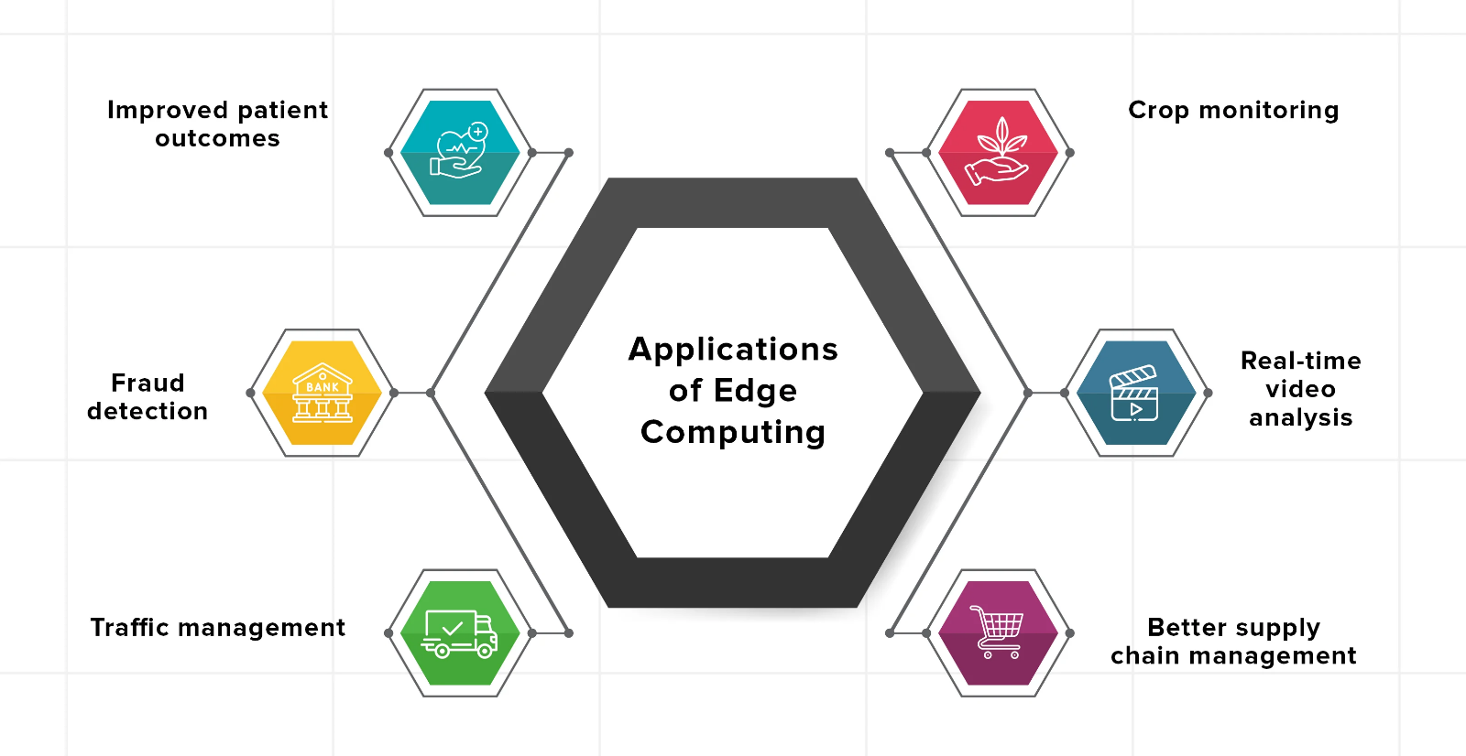

**Fig 24:** Crucial Applications of Edge Computing in agriculture.

**6.5** **Challenges and Considerations:**

Despite its numerous benefits, edge computing in agriculture presents several challenges, including:

**6.5.1. Integration Complexity:**

Integrating diverse IoT devices and sensors into a cohesive edge computing ecosystem requires compatibility, interoperability, and standardized protocols. Farmers may face challenges in selecting, deploying, and maintaining edge computing solutions that align with their specific operational needs and existing infrastructure.

**6.5.2. Data Quality and Reliability:**

The reliability and accuracy of data collected by IoT devices can vary based on environmental conditions, sensor placement, and calibration. Ensuring data quality and consistency is crucial for generating reliable insights and decision-making in agricultural applications.

**6.5.3. Skill and Knowledge Requirements:**

Effective implementation of edge computing in agriculture demands technical expertise in IoT deployment, data analytics, and system integration. Farmers and agricultural professionals may require training and support to leverage edge computing technologies effectively and derive maximum benefits from real-time data processing.

**6.6 Future Directions and Innovations:**

The future of edge computing in agriculture holds promise for further advancements and innovations:

**6.6.1. Edge AI and Machine Learning:**

Integrating artificial intelligence (AI) and machine learning (ML) algorithms at the edge enhances predictive analytics and autonomous decision-making capabilities. Edge AI solutions can analyze complex data patterns, predict crop yields, and optimize resource allocation in real-time, without relying heavily on cloud-based processing.

**6.6.2. Edge-to-Cloud Integration:**

Hybrid edge-to-cloud architectures combine the strengths of local data processing with the computational power of centralized cloud servers. This integration enables seamless data sharing, collaborative analytics, and scalability, supporting comprehensive agricultural management solutions.

**6.6.3. Edge Computing Standards and Frameworks:**

Developing industry standards and frameworks for edge computing in agriculture promotes interoperability, data security, and scalability across different farm operations. Standardized protocols and best practices facilitate the adoption of edge computing solutions by providing clear guidelines for deployment and integration.

Edge computing represents a transformative technology for agriculture, enabling farmers to harness real-time data insights, enhance operational efficiency, and achieve sustainable farming practices. By processing data locally at the edge of the network, agriculture can overcome challenges related to latency, data security, and scalability, paving the way for a digital revolution in how crops are grown, monitored, and managed. As edge computing continues to evolve, its integration with AI, IoT, and machine learning promises to redefine the future of precision agriculture, ensuring food security and environmental sustainability in a rapidly changing world.

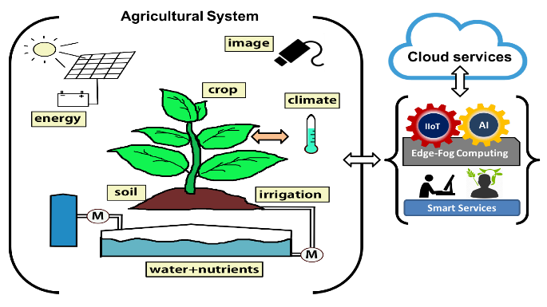

**Fig 23:** process showing Edge Computing

.

**8. Precision Agriculture Technologies:**

Precision agriculture has emerged as a transformative approach in modern farming, leveraging advanced technologies to optimize crop management practices and enhance agricultural sustainability. By integrating data-driven insights and precise control mechanisms, precision agriculture aims to maximize crop yields while minimizing input costs such as water, fertilizers, and pesticides. This paper explores key technologies and their applications within the framework of automated disease detection and pest classification in potato farming.

**7.1 Understanding Precision Agriculture Technologies:**

Precision agriculture encompasses a range of technologies and methodologies designed to tailor farming practices to specific field conditions, crop requirements, and environmental factors. Central to precision agriculture is the use of data analytics, remote sensing, and automated systems to achieve targeted and efficient agricultural management.

**7.2 Components of Precision Agriculture Technologies:**

**7.2.1. Remote Sensing:**

Remote sensing technologies, including drones and satellites equipped with multispectral and hyperspectral sensors, capture high-resolution imagery of agricultural fields. These images provide detailed insights into crop health, nutrient levels, and pest infestations. Remote sensing data is processed using AI algorithms to generate actionable information, such as disease outbreak maps or pest distribution patterns, enabling proactive management strategies.

**7.2.2. Variable Rate Technology (VRT):**

VRT systems optimize input application rates, such as fertilizers and pesticides, based on real-time data and spatial variability within fields. By applying inputs at precise locations and rates, VRT minimizes wastage, improves resource use efficiency, and reduces environmental impact. For instance, soil sensorscombined with VRT can adjust nitrogen application rates according to soil nutrient levels, ensuring optimal crop nutrition without over-application.

**7.3 Applications of Precision Agriculture Technologies:**

**7.3.1. Automated Disease Detection:**

Precision agriculture technologies facilitate automated disease detection through AI-driven image analysis and sensor data interpretation. AI algorithms trained on large datasets can identify disease symptoms, such as leaf discoloration or fungal growth, with high accuracy. For example, image recognition software integrated with drone-mounted cameras can detect early signs of late blight in potato crops, enabling timely intervention and disease management.

**7.3.2. Smart Irrigation Management:**

Advanced irrigation management systems utilize soil moisture sensors and weather data to optimize water application schedules and volumes. AI algorithms analyze real-time data to adjust irrigation strategies based on crop water requirements and environmental conditions. Smart irrigation technologies help prevent water stress, improve crop water use efficiency, and mitigate risks of over-irrigation or waterlogging in potato farming. These systems can also integrate with other smart farming technologies, such as automated nutrient delivery systems, to provide a comprehensive approach to crop health and productivity. Additionally, they can generate detailed reports and predictive analytics to aid farmers in making informed decisions and planning for future irrigation needs.

**7.4 Benefits of Precision Agriculture Technologies:**

**7.4.1. Enhanced Crop Yields and Quality:**

By optimizing inputs and management practices, precision agriculture technologies enhance crop yields and quality. AI-driven insights enable farmers to make data-driven decisions, improving plant health, minimizing yield losses due to pests or diseases, and ensuring consistent crop production.

**7.4.2. Resource Efficiency and Sustainability:**

Precision agriculture reduces resource wastage and environmental impact by precisely targeting inputs according to crop needs and field conditions. Efficient use of water, fertilizers, and pesticides minimizes runoff, soil erosion, and chemical residues in groundwater, promoting sustainable farming practices and environmental stewardship.

**7.5 Challenges and Considerations:**

Despite its advantages, precision agriculture faces several challenges that require attention:

**7.5.1. Initial Investment and Technology Adoption:**

The adoption of precision agriculture technologies requires significant initial investment in equipment, sensors, and data analytics platforms. Farmers may face barriers such as cost, technical expertise, and infrastructure compatibility, hindering widespread adoption in small-scale farming operations.

**7.5.2. Data Integration and Interoperability:**

Integrating data from diverse sources, such as sensors, satellites, and farm machinery, poses challenges related to data standardization, compatibility, and interoperability. Effective data management and integration platforms are essential to maximize the utility of precision agriculture technologies and derive actionable insights.

**7.6 Future Directions and Innovations:**

The future of precision agriculture is promising with ongoing advancements and innovations:

**7.6.1. AI and Machine Learning in Agriculture:**

Further integration of AI and machine learning algorithms will enhance predictive analytics, autonomous decision-making, and adaptive management practices in agriculture. AI models capable oflearning fromcontinuous data streams will enable real-time adjustments in farming operations, optimizing efficiency and productivity.

**7.6.2. Blockchain Technology for Traceability and Transparency:**

Blockchain technology can enhance supply chain transparency and product traceability in agriculture. By securely recording transactions and data exchanges, blockchain facilitates provenance verification, quality assurance, and compliance with regulatory standards, promoting trust and accountability across the agricultural value chain.

Precision agriculture technologies play a pivotal role in advancing automated disease detection and pest classification in potato farming. By harnessing data analytics, remote sensing, and automated systems, precision agriculture enhances crop management practices, improves resource efficiency, and promotes sustainable farming practices. As technology continues to evolve, the integration of AI, IoT, and data-driven approaches will drive innovation in agriculture, ensuring food security and environmental sustainability in a rapidly changing global landscape.

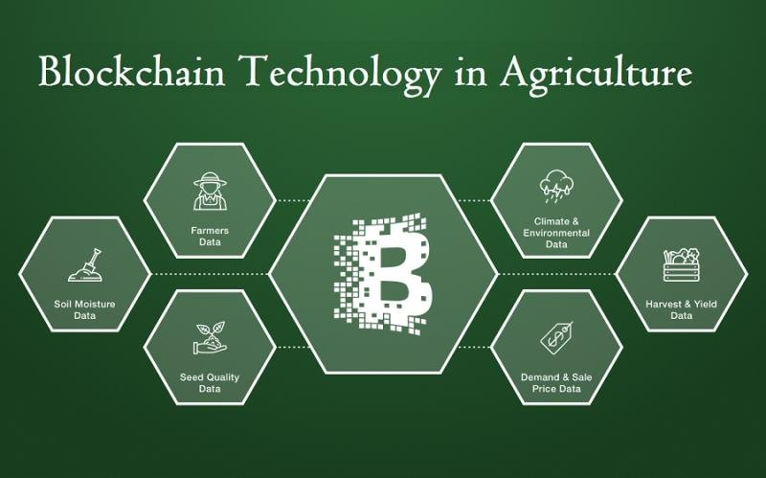

**Fig 24:** Sample Blockchain Technology applied in agriculture

**7.6.3 Implementation Details:**

***7.6.3.1 Naïve Bayes theorem***

NB classiﬁers are a subset of fundamental “probabilistic classiﬁers”based on the NB theorem and strong feature independence assumptions. They areamong the most basic BN models, but they can achieve higher accuracy when combined with kernel density estimation. This theorem computes the likelihoodof a subsequent event of the preceding event. Mathematically Bayes’ theorem canbe represented as

Crops: Potato

Accuracy Training set: 88.22

Testing set: 88.19

The above data mentioned the accuracy of the potato crop. We have estimated the accuracy in terms of training as well as testing set and found NB algorithm gives 89.32 training and 90.32 and 90.12 testing accuracy.

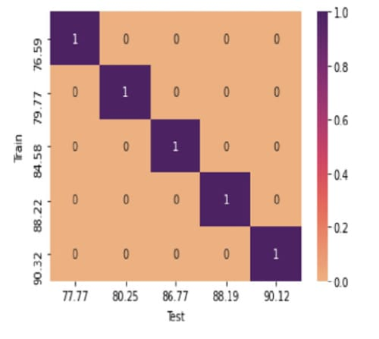

**Fig 25:** Categorizing of different crops including potato using Naive Bayesian (graph)

Formula used : P(A|B)=fracP(B|A)P(A)=fracP(B|A){P(B)}

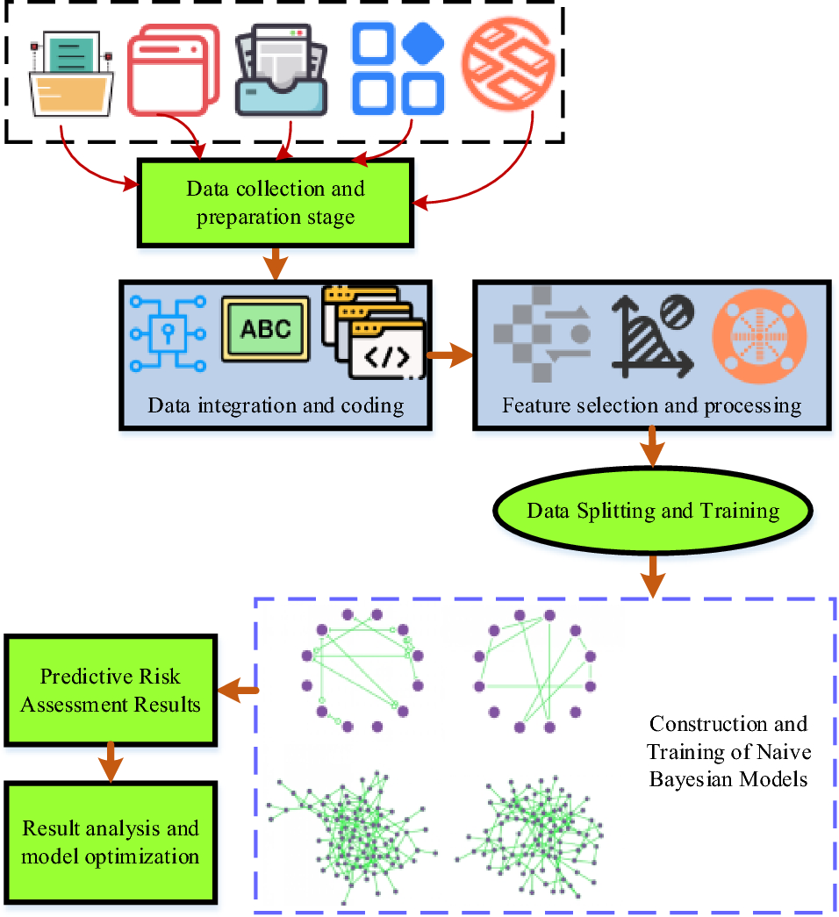

**Fig 26:** Naive Bayesian algorithm process.

***7.6.3.2 Support Vector Machine (SVM):***

A supervised ML technique used to solve classiﬁcation and regression problems. However, this is preferably used to solve problems based on categorization types. Each data item is represented as a point inn-dimensional space (where n is the number of features chosen), with the value of each feature representing the SVM algorithm’s value of a particular coordinate. After that, the classiﬁcation is completed by locating the hyper plane that best distinguishes the two classes. The following is the hyper plane equation used to divide the points (for classification):

H: wT(x)+b=()

Here: b=the hyper plane equation’s intercept and bias term

Crop: Potato

Accuracy training set: 92.26

Testing set: 90.19

The above data mentioned shows the potato crop prediction using SVM.

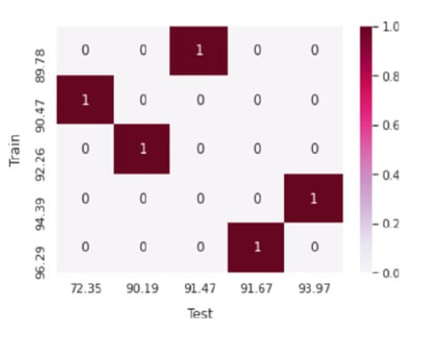

**Fig 27:** Categorizing of different crops including potato using Support Vector Machine (graph).

In all we can say Machine learning is a useful tool in today’s world for analyzing massive amounts of data and producing more accurate results and predictions. Our research demonstrated and provided accurate results for the ﬁve crops that were chosen as a sample for yield prediction. Hence, we were able to conﬁrm that machine learning algorithms may also be used to predict various illnesses impacting crops over multiple seasons and across a variety of crops because our training set and testing data are practically identical. To achieve the best level of classiﬁcation accuracy, careful selection of preprocessing data methodologies and machine learning technologies is required. As a result, more machine learning-based technologies are required to predict various sorts of illnesses impacting diverse. SVM beats the other two methods, with Gram’s training accuracy of 96.29% and testing accuracy of 95.67% as prediction is concerned.

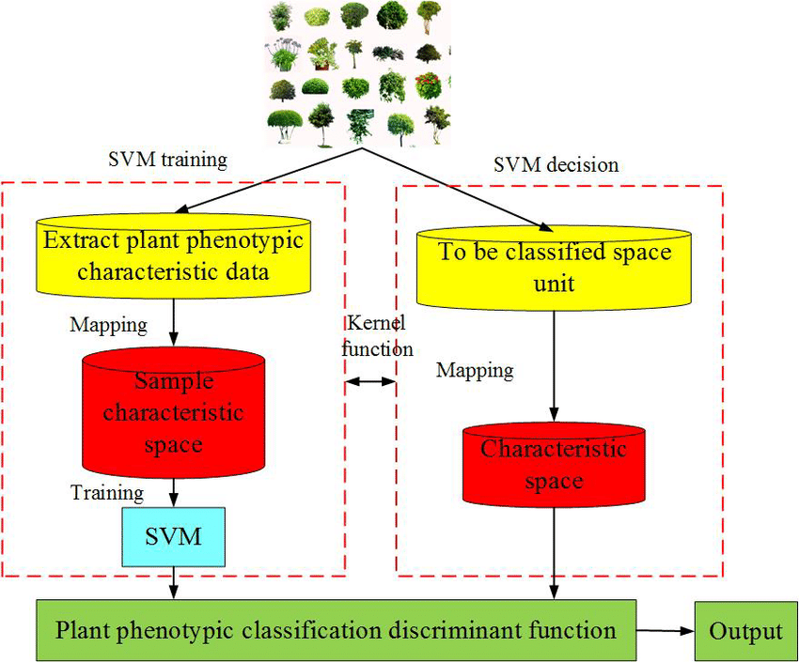

**Fig 28:** Flowchart of Support Vector machine (SVM)

**9.** **Robotics and Automation in Agriculture:**

The integration of robotics and automation in agriculture represents a significant leap forward in the quest for efficient and sustainable farming practices. By employing autonomous machines and robotic systems, farmers can achieve higher precision, reduce labor costs, and enhance overall productivity. This paper explores the role of robotics and automation in disease detection, pest control, and crop management, with a particular focus on their applications in potato farming.

**8.1 Robotics and Automation:**

Robotics and automation involve the use of autonomous or semi-autonomous machines to perform agricultural tasks traditionally carried out by human labor. These technologies range from simple automated tools to sophisticated robotic systems capable of performing complex operations with minimal human intervention.

**8.2** **Components of Robotics and Automation in Agriculture:**

**8.2.1. Autonomous Tractors and Machinery:**

Autonomous tractors and machinery are equipped with GPS, sensors, and AI to perform various farming tasks, such as plowing, seeding, and harvesting, with high precision. These machines can operate continuously without fatigue, optimizing field operations and reducing dependency on manual labor.

**8.2.2. Robotic Weed Control:**

Robotic weeders use computer vision and AI algorithms to identify and remove weeds from fields. These robots precisely target weeds, minimizing the use of herbicides and preserving soil health. By automating weed control, farmers can achieve more effective weed management and reduce the environmental impact of chemical herbicides.

**8.2.3. Drone Technology:**

Drones equipped with cameras and sensors provide aerial surveillance of crop fields. They can capture high-resolution images and gather data on crop health, pest infestations, and soil conditions. Drones offer a bird's-eye view of large fields, enabling farmers to monitor and manage crops more efficiently.

**8.3 Applications of Robotics and Automation in Potato Farming:**

**8.3.1. Automated Disease Detection:**

Robots equipped with advanced imaging systems and AI algorithms can detect disease symptoms in potato plants at an early stage. These robots move through fields, capturing images of plants and analyzing them for signs of diseases such as late blight. Early detection allows for timely intervention, reducing crop losses and improving yield quality.

**8.3.2. Precision Pest Control:**

Autonomous pest control robots can identify and target specific pest populations within fields. Using AI and sensors, these robots apply pesticides precisely where needed, minimizing chemical use and protecting beneficial insects. This targeted approach enhances pest management efficiency and supports sustainable farming practices.

**8.3.3. Harvesting and Sorting:**

Robotic harvesters can efficiently harvest potatoes, reducing the need for manual labor. These robots are equipped with sensors to detect the ripeness and size of potatoes, ensuring optimal harvesting. Additionally, robotic sorting systems can classify harvested potatoes based on quality, size, and defects, streamlining the post-harvest process.

**8.4** **Benefits of Robotics and Automation in Agriculture:**

**8.4.1. Labor Efficiency:**

Robotic systems reduce the reliance on manual labor, addressing labor shortages and increasing operational efficiency. Autonomous machines can work continuously, performing tasks with precision and consistency, which enhances productivity and reduces labor costs.

**8.4.2. Precision and Accuracy:**

Robots equipped with advanced sensors and AI algorithms perform agricultural tasks with high precision and accuracy. This precision reduces input wastage, improves crop health, and minimizes environmental impact. For example, precision spraying robots apply pesticides only where needed, reducing chemical usage and protecting the environment.

**8.4.3. Enhanced Data Collection and Analysis:**

Robotic systems generate vast amounts of data on crop health, soil conditions, and pest populations. This data can be analyzed using AI and machine learning algorithms to provide actionable insights for better decision-making. Enhanced data collection and analysis enable farmers to adopt data-driven strategies for crop management.

**8.5 Challenges and Considerations:**

While robotics and automation offer numerous benefits, several challenges must be addresse**d:**

**8.5.1. High Initial Costs:**

The implementation of robotic systems requires significant capital investment. The cost of purchasing and maintaining autonomous machines can be prohibitive for small-scale farmers. Financial support and incentives are necessary to promote the adoption of robotics in agriculture.

**8.5.2. Technical Complexity:**

Operating and maintaining robotic systems requires technical expertise. Farmers may need training and support to effectively use and troubleshoot these technologies. Collaboration with technology providers and agricultural extension services is crucial to ensure successful adoption.

**8.5.3. Integration with Existing Systems:**

Integrating robotic systems with existing agricultural practices and infrastructure can be challenging. Compatibility issues and the need for system upgrades may hinder seamless integration. Developing standardized protocols and interoperable systems is essential for efficient implementation.

**8.6 Future Directions and Innovations:**

The future of robotics and automation in agriculture is promising, with ongoing advancements and innovations:

**8.6.1. AI-Driven Autonomous Systems:**

Future robotic systems will leverage AI and machine learning to achieve greater autonomy and adaptability. These systems will be capable of learning from their environment and optimizing their performance over time, further enhancing efficiency and productivity.

**8.6.2. Collaborative Robots (Cobots):**

Cobots are designed to work alongside human labor, complementing and enhancing their capabilities. In agriculture, cobots can assist with tasks such as planting, weeding, and harvesting, improving overall efficiency and reducing physical strain on workers.

**8.6.3. Advanced Sensing and Imaging Technologies:**

Advancements in sensing and imaging technologies will enhance the capabilities of robotic systems. High-resolution cameras, hyperspectral sensors, and thermal imaging will provide more detailed and accurate data on crop health, enabling precise interventions.

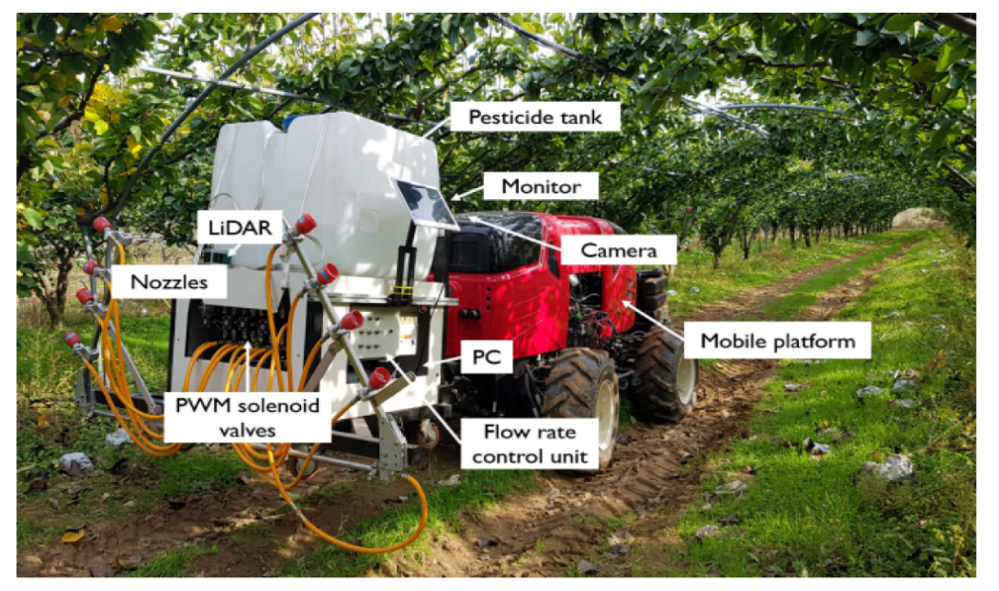

**Fig 29:** Showing a demo of robotics in agriculture

Robotics and automation are revolutionizing agriculture, offering innovative solutions for disease detection, pest control, and crop management. By integrating autonomous machines and advanced technologies, farmers can achieve higher precision, reduce labor costs, and enhance overall productivity. The continued development and adoption of robotics and automation will play a pivotal role in ensuring sustainable and efficient farming practices, meeting the challenges of modern agriculture, and securing food production for the future.

### 10. Conclusion

The integration of deep learning and Internet of Things (IoT) technologies in potato farming has demonstrated significant potential in enhancing the efficiency and effectiveness of disease detection and pest classification. This study explored the deployment of these advanced technologies, highlighting several key findings and implications.

**Key Findings**

1. **Accuracy and Precision**: The deep learning models employed for disease detection and pest classification exhibited high accuracy rates. By leveraging convolutional neural networks (CNNs) and other sophisticated algorithms, the system was able to identify various diseases and pests with remarkable precision.
2. **Real-time Monitoring**: The IoT framework facilitated real-time monitoring of potato crops. Sensors and connected devices continuously collected data, enabling timely detection of anomalies and swift response to potential threats.
3. **Scalability and Adaptability**: The proposed system proved to be scalable and adaptable to different farming environments. It can be extended to other crops and adapted to varying climatic conditions, making it a versatile tool for precision agriculture.
4. **Economic Benefits**: Early detection and accurate classification of diseases and pests can significantly reduce crop losses, thereby improving yield and profitability for farmers. The automated nature of the system also reduces the need for manual labor and expert intervention, leading to cost savings.
5. **Sustainability**: By promoting targeted interventions, the system supports sustainable farming practices. It minimizes the overuse of pesticides and chemicals, thereby reducing environmental impact and promoting healthier crop production.

**Implications**

The findings underscore the transformative potential of integrating deep learning and IoT in agriculture. This approach not only enhances crop management but also aligns with the broader goals of precision agriculture, which aims to optimize resource use and improve crop yields.

Furthermore, the success of this system in potato farming sets a precedent for its application in other agricultural sectors, potentially leading to widespread adoption of smart farming technologies.

**Future Directions**

While the study presents promising results, several areas warrant further exploration:

1. **Enhanced Algorithms**: Continued refinement of deep learning algorithms to improve accuracy and reduce false positives/negatives.
2. **Integration with Other Technologies**: Combining IoT and deep learning with other emerging technologies, such as drones and satellite imagery, for more comprehensive monitoring and analysis.
3. **User-Friendly Interfaces**: Developing more intuitive user interfaces to facilitate ease of use by farmers, irrespective of their technical expertise.
4. **Field Trials**: Conducting extensive field trials across diverse geographic regions to validate the system’s effectiveness and adaptability.
5. **Data Privacy and Security**: Ensuring robust data privacy and security measures to protect farmers' data and build trust in the technology.

In conclusion, the convergence of deep learning and IoT in automated disease detection and pest classification marks a significant advancement in agricultural technology. It holds the promise of revolutionizing potato farming, leading to higher productivity, reduced environmental impact, and greater economic benefits for farmers. Continued research and development in this domain will be crucial to fully realize its potential and drive the future of smart agriculture.

**References:**

1. Kamilaris, A., & Prenafeta-Boldú, F. X. (2018). Deep learning in agriculture: A survey. Computers and Electronics in Agriculture, 147, 70-90.

2. Mohanty, S. P., Hughes, D. P., & Salathé, M. (2016). Using deep learning for image-based plant disease detection. Frontiers in Plant Science, 7, 1419.

3. Liakos, K. G., Busato, P., Moshou, D., Pearson, S., & Bochtis, D. (2018). Machine learning in agriculture: A review. Sensors, 18(8), 2674.

4. Rathore, M. M., Son, N. T., & Park, J. H. (2017). IoT-based big data: From smart city towards next generation super city planning. International Journal of Smart Home, 11(2), 215-228.

5. Verdouw, C. N., Wolfert, J., Beulens, A. J. M., & Rialland, A. (2016). Virtualization of food supply chains with the internet of things. Journal of Food Engineering, 176, 128-136.

6. Wageningen University & Research (2019). Smart farming with IoT-based applications.

7. University of California, Davis (2018). Automated disease detection using drones in agriculture.

8. Kamilaris, A., & Prenafeta-Boldú, F. X. (2018). Deep learning applications in agriculture: A review. Computers and Electronics in Agriculture, 147, 70-90.

9. Tsouros, D. C., Bibi, S., & Sarigiannidis, P. (2019). Early pest detection in greenhouses using IoT. Sensors, 19(19), 4486.

10. Wolfert, S., Ge, L., Verdouw, C., & Bogaardt, M. J. (2017). Big data in smart farming – A review. Agricultural Systems, 153, 69-80.

11. Commonwealth Scientific and Industrial Research Organisation (CSIRO) (2019). Precision agriculture with IoT sensors.

12. Brahimi, M., Arsenovic, M., Laraba, S., Sladojevic, S., Boukhalfa, K., & Moussaoui, A. (2018). Deep learning for plant diseases: Detection and saliency map visualization. Computers and Electronics in Agriculture, 157, 168-179.

13. Indian Agricultural Research Institute (IARI) (2018). Smart irrigation systems in Indian agriculture.

14. Ramcharan, A., Baranowski, K., McCloskey, P., Ahmed, B., Legg, J., & Hughes, D. P. (2017). Deep learning for image-based cassava disease detection. Frontiers in Plant Science, 8, 1852.

15. Volcani Center (2019). Automated greenhouse management system in Israel.

16. Ray, P. P. (2017). Internet of things for smart agriculture: Technologies, practices and future direction. Journal of Ambient Intelligence and Smart Environments, 9(5), 395-420.

17. Mahlein, A. K. (2016). Plant disease detection by imaging sensors – Parallels and specific demands for precision agriculture and plant phenotyping. Advances in Agronomy, 141, 1-36.

18. Zhejiang University (2018). Use of UAVs for crop monitoring in China.

19. Dyrmann, M., Jørgensen, R. N., & Midtiby, H. S. (2016). A comparison of methods for weed detection in sugar beet fields based on sensor fusion. Computers and Electronics in Agriculture, 144, 123-133.

20. Brazilian agricultural Research Corporation (Embrapa) (2019). IoT-based livestock monitoring in Brazil.

21. Zhang, Q., Wu, J., & Li, Q. (2018). Precision agriculture technologies and practices: A review. IEEE Access, 6, 62801-62818.

22. University of British Columbia (2019). Soil health monitoring using IoT sensors in Canada.

23. McCulloch, M., Heath, R., & Hammond, L. (2019). Artificial intelligence in agriculture. Agricultural Systems, 175, 1-13.

24. Fraunhofer Institute for Industrial Engineering IAO (2018). IoT-enabled pest management system in Germany.

25. Kang, Y., & Othman, M. (2016). IoT and machine learning for crop management. IEEE Internet of Things Journal, 3(6), 952-963.

26. Tokyo University of Agriculture and Technology (2019). IoT in aquaponics systems in Japan.

27. Jawad, H. M., Nordin, R., Gharghan, S. K., Jawad, A. M., & Ismail, M. (2017). Energy-efficient wireless sensor networks for precision agriculture: A review. Sensors, 17(8), 1781.

28. University of Bologna (2018). Smart beehives using IoT in Italy.

29. Deval, P. H., Mulani, H. H., & Lahane, S. P. (2018). A survey on IoT in agriculture: Applications, technologies, and challenges. Computers and Electronics in Agriculture, 155, 378-390.

30. University of Reading (2019). Remote sensing for precision agriculture in the UK.

31. Apat, S. K., Mishra, J., Raju, S. K., & Padhy, N. (2019). IoT-assisted crop monitoring using machine learning algorithms for smart farming. In Next Generation of Internet of Things (pp. 115-130).

32. Yang, X., & Guo, T. (2019). Machine learning in plant disease research. Machine Learning, 342, 1-18.

33. Jawade, P. B., et al. (2020). Disease prediction of mango crop using machine learning and IoT. In Advances in Decision Sciences, Image Processing, Security and Computer Vision (pp. 254-260). Springer, Cham.

34. Akulwar, P. (2020). A recommended system for crop disease detection and yield prediction using machine learning approach. In Recommender System with Machine Learning and Artificial Intelligence: Practical Tools and Applications in Medical, Agricultural, and Other Industries (pp. 141-163).

35. Medar, R., Rajpurohit, V. S., & Shweta, S. (2019). Crop yield prediction using machine learning techniques. In 2019 IEEE 5th International Conference for Convergence in Technology (I2CT) (pp. 1-6). IEEE.

36. Sharma, B., Yadav, J. K. P. S., & Yadav, S. (2020). Predict crop production in India using machine learning technique: A survey. In 2020 8th International Conference on Reliability, Infocom Technologies and Optimization (Trends and Future Directions) (ICRITO) (pp. 1-5). IEEE.

37. Bondre, D. A., & Mahagaonkar, S. (2019). Prediction of crop yield and fertilizer recommendation using machine learning algorithms. International Journal of Engineering Applied Sciences and Technology, 4(5), 371-376.

38. Kumar, Y. J. N., et al. (2020). Supervised machine learning approach for crop yield prediction in agriculture sector. In 2020 5th International Conference on Communication and Electronics Systems (ICCES) (pp. 1-6). IEEE.

39. Jain, A., et al. (2019). A review of plant leaf fungal diseases and its environment speciation. Bioengineered, 10(1), 409-424.

40. Kumari, P., et al. (2020). Prediction of crop yield using SVM approach with the facility of E-MART system. EasyChair Preprint No. 2301.

.